MATTITUCK – LAUREL LIBRARY

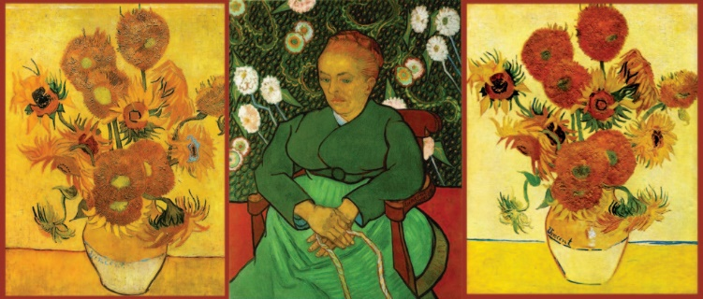

Van Gogh wanted to be known as the sunflower painter.

He painted several versions of sunflowers, some of which he painted to decorate the room of Paul Gaugin. Explore the symbolism, in Van Gogh’s mind, of these iconic images and how the artist planned to display them.

Van Gogh: “The Sunflower Is Mine”

*“The sunflower is mine,” Van Gogh exclaimed in a letter to his brother Theo. Then later he wrote, “I find comfort in sunflowers.”*

Thursday, August 11th, 11 am - noon