Title | Author | Duration
 |  | 30 minutes
 |  | 30 minutes
 |  | 30 minutes
 |  | 30 minutes
 |  | 30 minutes
 |  | 30 minutes
 |  | 30 minutes
*30 minutes
Come in for a drawer prize!!
 |  | 30 minutes
 |  | 30 minutes
 |  | 30 minutes
 |  | 30 minutes
 |  | 30 minutes
 |  | 30 minutes
 |  | 30 minutes
*30 minutes
Come in for a drawer prize!
 |  | 30 minutes
 |  | 30 minutes
 |  | 30 minutes
 |  | 30 minutes
 |  | 30 minutes
 |  | 30 minutes
 |  | 30 minutes
*30 minutes
You have completed the program!! Come in for raffle tickets and a drawer prize.

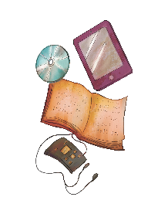
TEEN SUMMER READING LOG
All Together Now
*Indicates that you are eligible to redeem your prize at the library!

